In-Class Evaluation

21_AIE_211

Introduction to Computer Networks– SEM-IV

Professor – Ganga Gowri

Submitted By: Vikhyat Bansal [CB.EN.U4AIE21076]



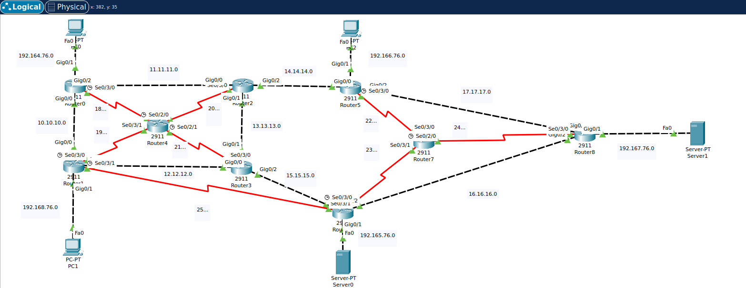1. network from Cisco Packet tracer (CPT) [Dynamic Routing]

2. ping results from the client to the server, include all possible client to server connections. [Dynamic Routing]

From PC-1 to Server-0

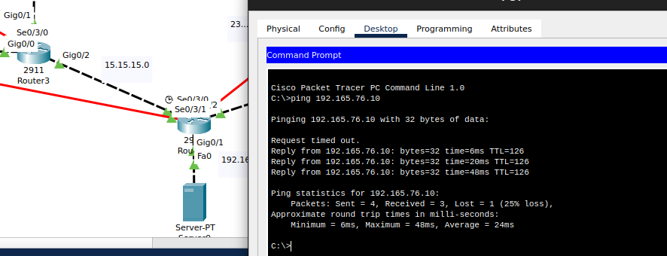

From PC-0 to Server-0

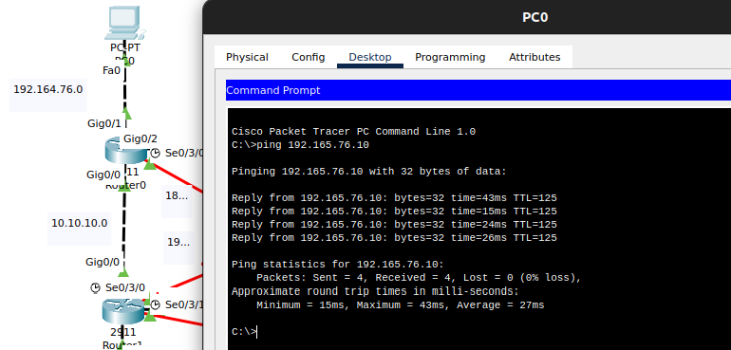

From PC-2 to Server-0

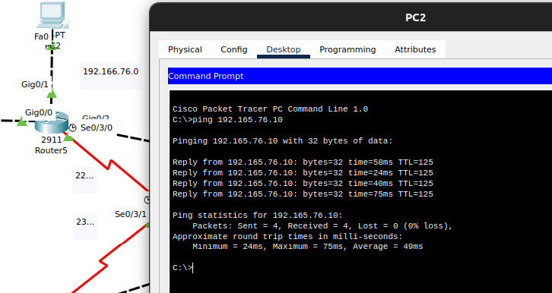

From PC-0 to Server-1

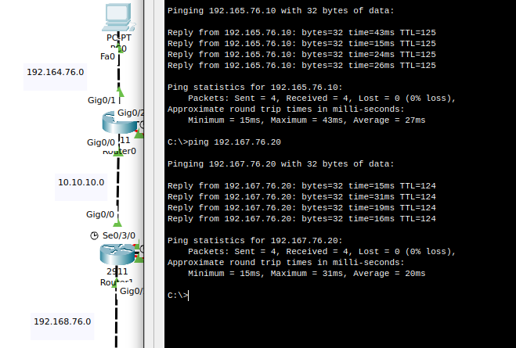

From PC-1 to Server-1

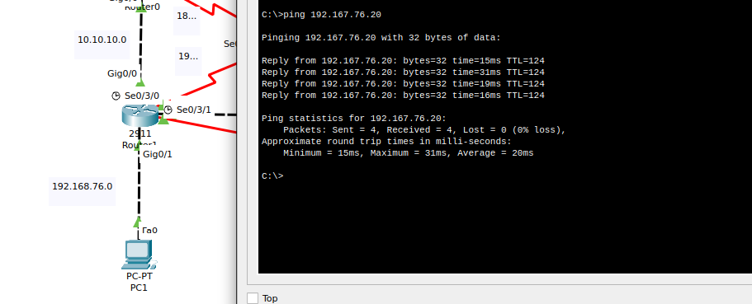

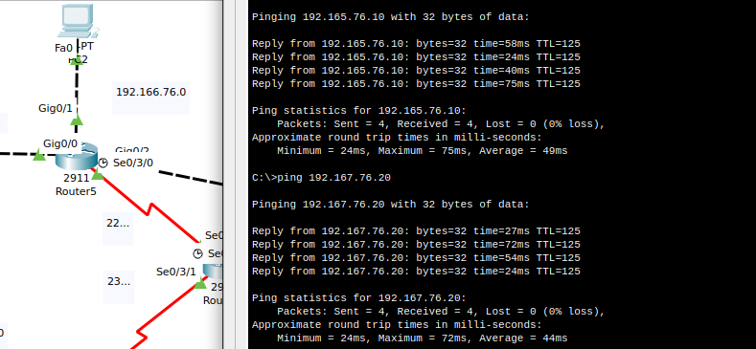From PC-2 to Server-1

3. Include labels for IP address of end systems and subnets [Dynamic Routing]



4. The screenshot of RIP routing of all router. [Only possible in-case of Dynamic Routing]

Router – 0

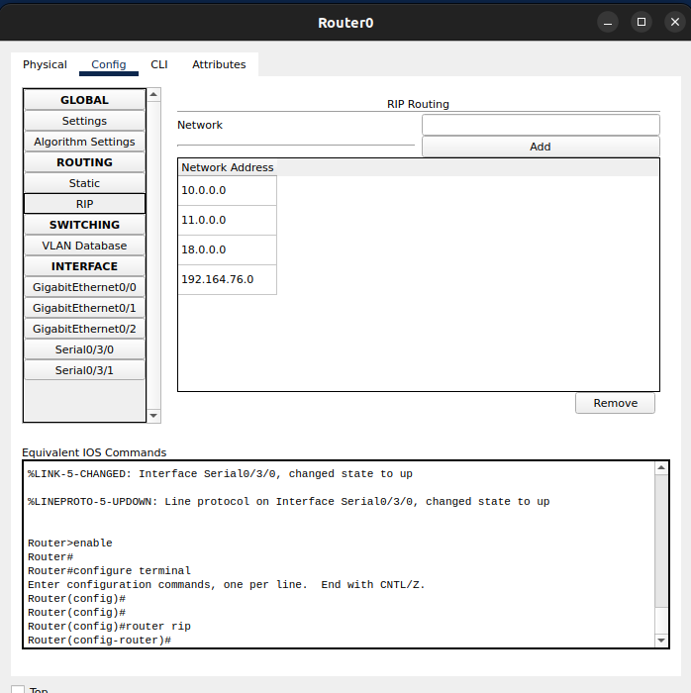

Router – 1

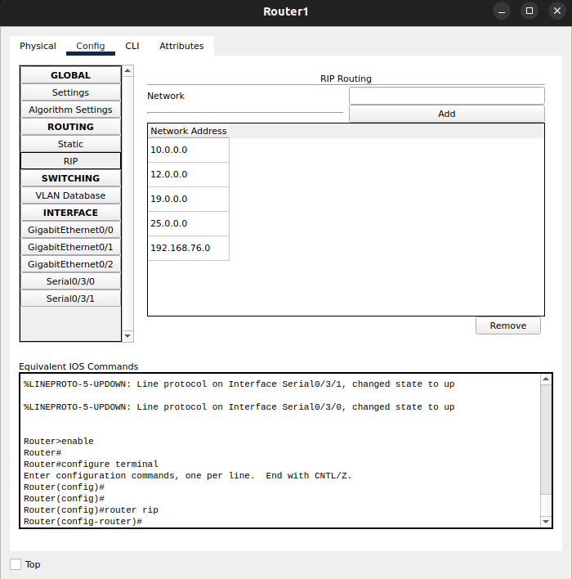

Router – 2

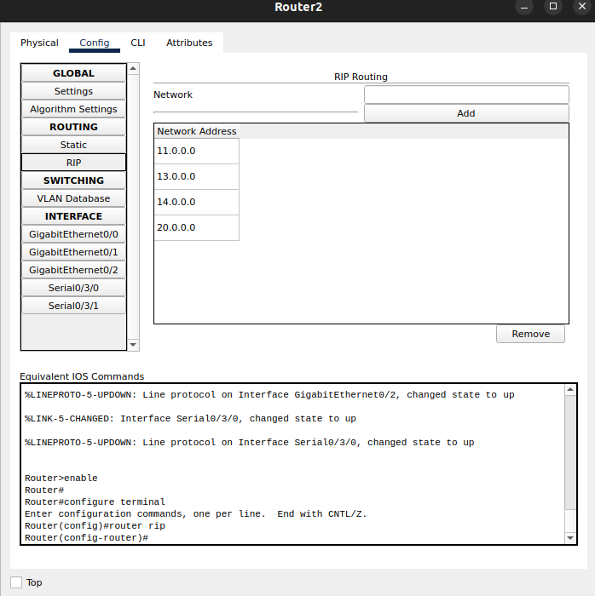

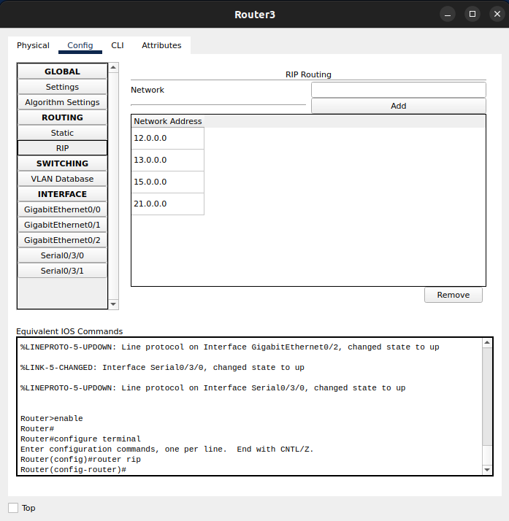Router - 3

Router – 4

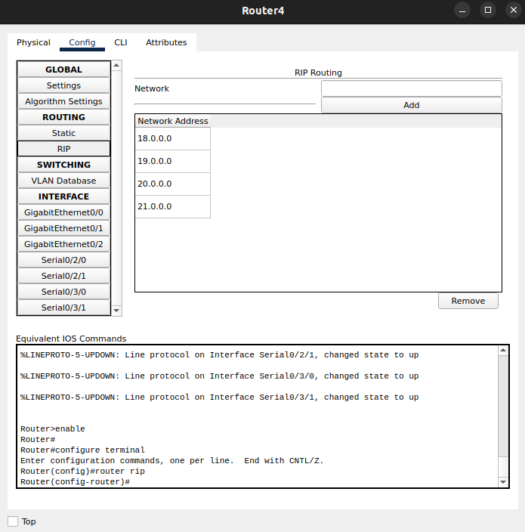

Router – 5

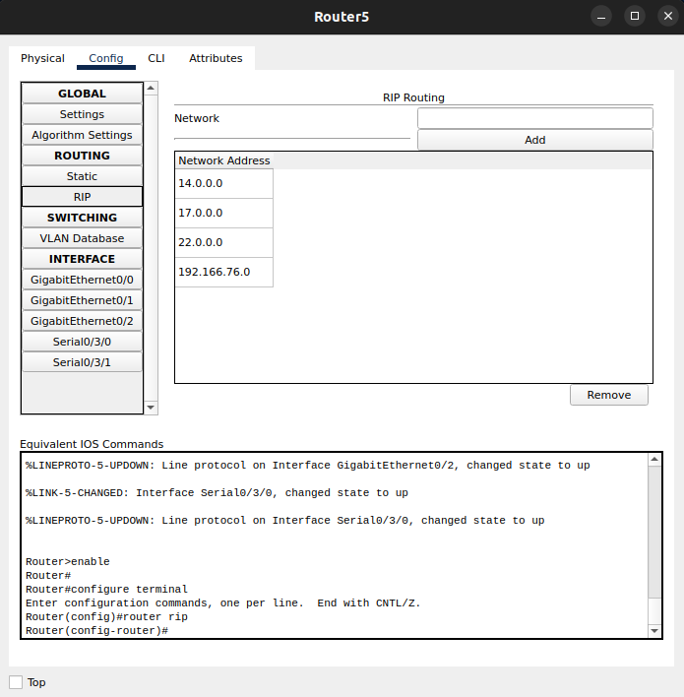

Router – 6

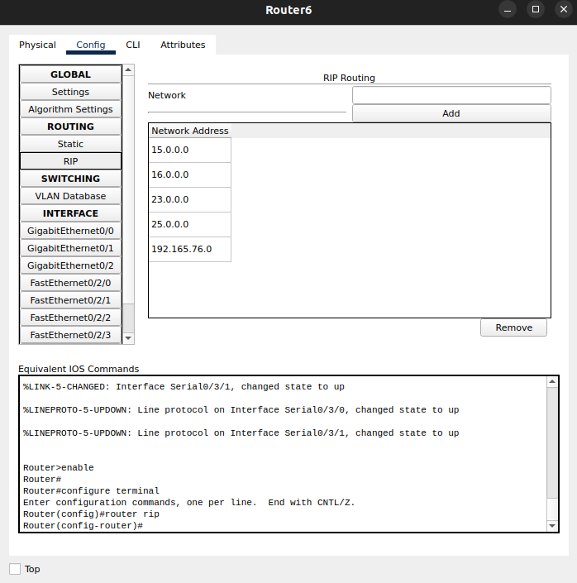

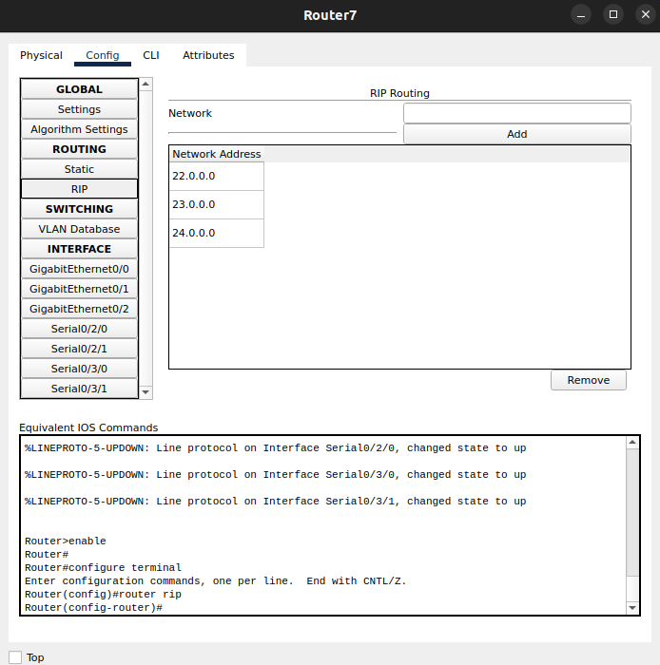Router – 7

Router – 8

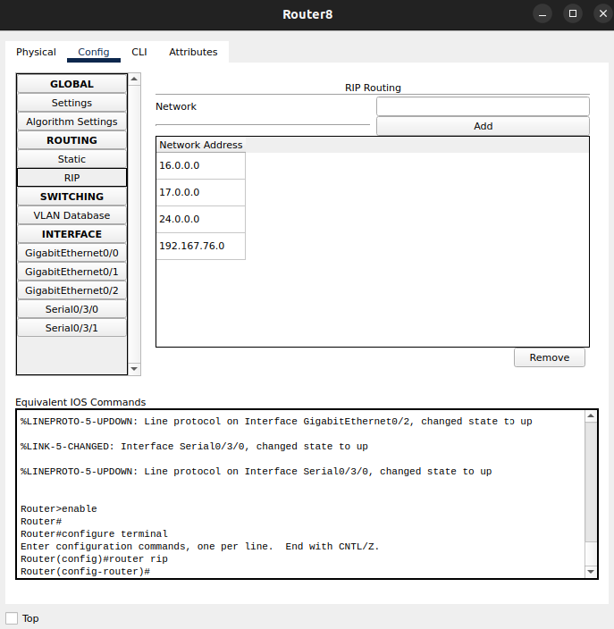

Link to Dynamic and Static Packet tracer file (Click on the link to download the file)

Dynamic - [Eval_Dynamic.pkt](https://amritavishwavidyapeetham-my.sharepoint.com/:u:/g/personal/cb_en_u4aie21076_cb_students_amrita_edu/EdPUGKzn9qVNvcL4uMFa7pMBJCf34EyItCKPWzCyiCMF8g?e=goJOA4)

Static - [Eval_Static.pkt](https://amritavishwavidyapeetham-my.sharepoint.com/:u:/g/personal/cb_en_u4aie21076_cb_students_amrita_edu/EWB7fzTKrS1IrfBrH_z08EMBphZUdhKXA2hJADZweE7b9w?e=wxBE1N)

THANK YOU!!